
SUBJECT : software construction and development LAB
ASSIGNMENT NO : 2
NAME : MOIN UD DIN
ID : CU-4365-2023
SECTION:D
DEPARTMENT: SOFTWARE ENGINEERING

- Create a tuple with 10 elements i-e- include Int, Float and String values.
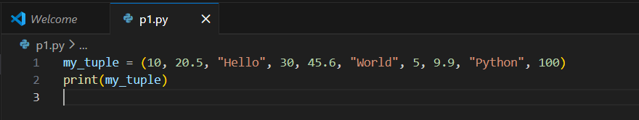

Output:-
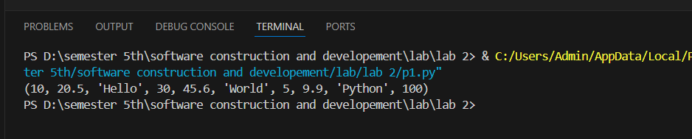

- Count a specific element that how many times appears in a tuple using count().

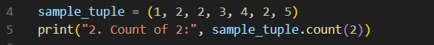
Output:-

- WAP which Convert tuple to list, modify it, and convert it back to a tuple.
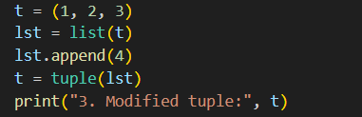
Output:-

- Create a nested tuple and access elements from the inner tuple.
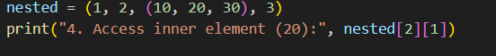
Output:-
- Def a set of 7 elements i-e- include Int, Float and String values.
Output:-
- Add a new element to a set using add() and multiple elements to a set using update().
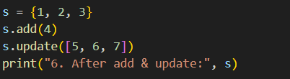
Output:-
- Remove an element from a set using both remove() and discard().
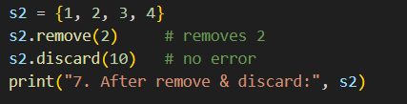
Output:-

- define two sets and find their union using union()
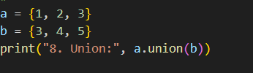
Output:-
- define two sets and find their intersection using intersection()
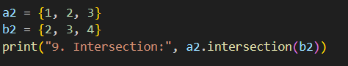
Output:-

- Create a dictionary of 3 students with their marks and print each key-value pair.
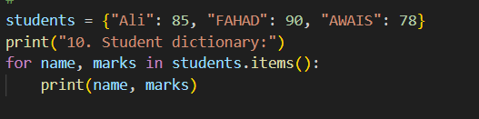
Output:-
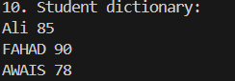

- Write a program to add a new key-value pair to a dictionary.
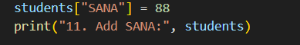
Output:-
- WAP to Access a value from the dictionary using its key.
Output:-
- WAP to Add a new key-value pair to a dictionary using assignment.
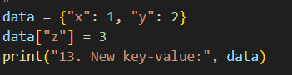
Output:
- WAP to Update an existing value in a dictionary.
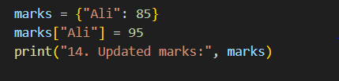
Output:-

- WAP to Remove a key-value pair using pop() and del.
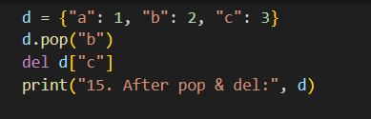
Output:-
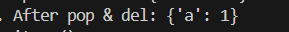
- Use .items() to print both keys and values in a loop.
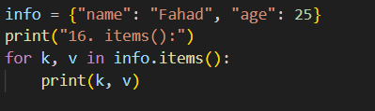
Output:-
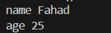
- Find the number of items in a dictionary using len().
Output:-
- Merge two dictionaries using the update() method.
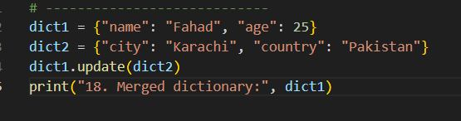
Output:-

